Today’s Opinion Writing Question
Remember to THINK, DECIDE and EXPLAIN out loud to your grown up before you start writing.

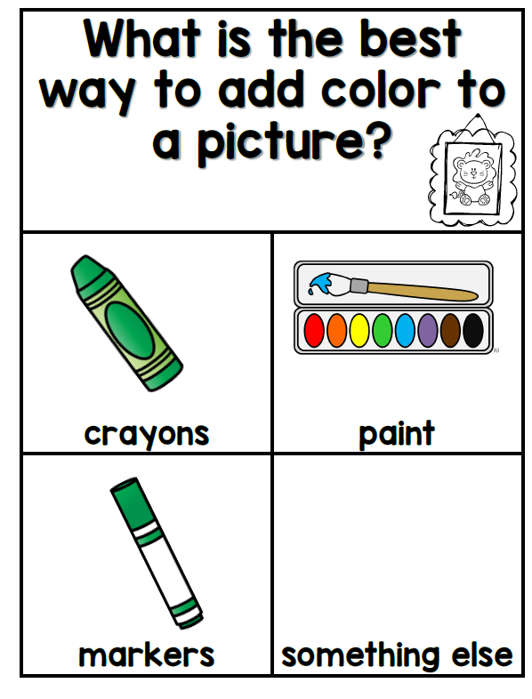
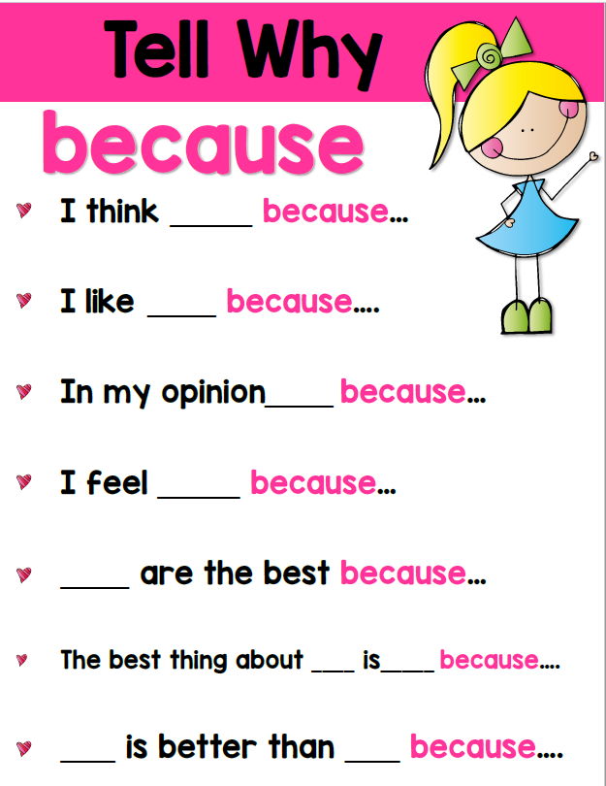

If your child states:
I think crayons are the best because there are so many colors.
Your child can draw a quick sketch of a box of crayons to help them remember what their idea is.
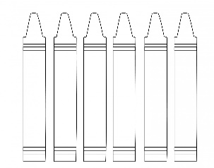
If they have difficulty getting started on the writing part – here is an idea. Draw lines on their paper, one for each word they told you. They can use the eraser end of their pencil as a pointer to tap on each line restating their opinion from above.

___ ___________ _________ __________ _________ __________

____________ _________ ________ ________ ___________ ______________.

Now they can write their opinion. Please allow your child to stretch out each word and write the sounds they hear. This will help them grow as writers! (The words do NOT have to be written as they are in the dictionary!)
Now they can add details, color and labels to their illustration.

Keep it short and sweet – no more than 20 minutes. The next time they sit down to write see if they can come up with yet another reason they think crayons are the best.

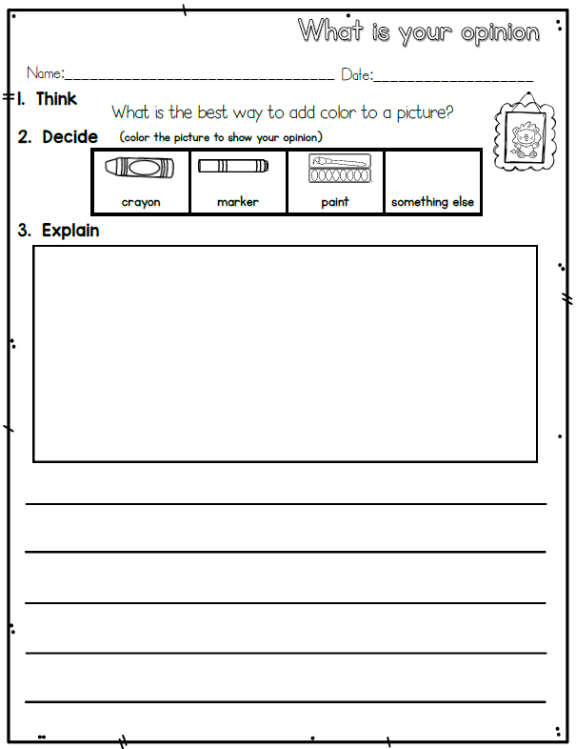

What are you doing well? GLOW Ask your grown up to look at your writing and complement you about your work.
Then ask them to help you look for 1 thing you can add to your writing to help you GROW as a writer using this rubric.
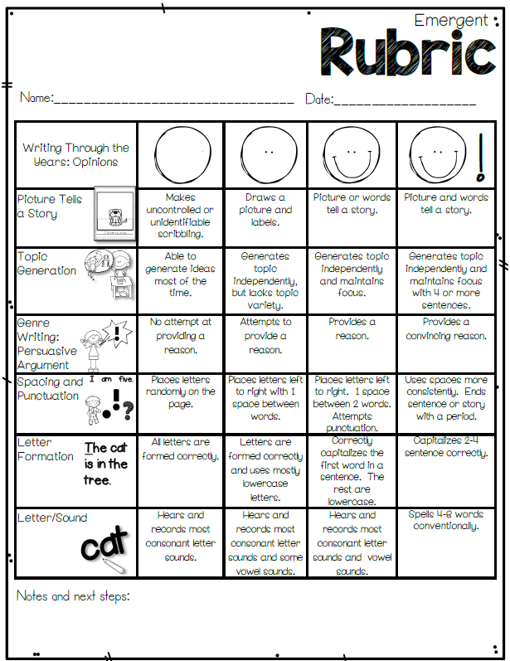
Extension: If you were able to get ALL on the Emergent Rubric – you are ready for the Early Writer Rubric on the next page.
