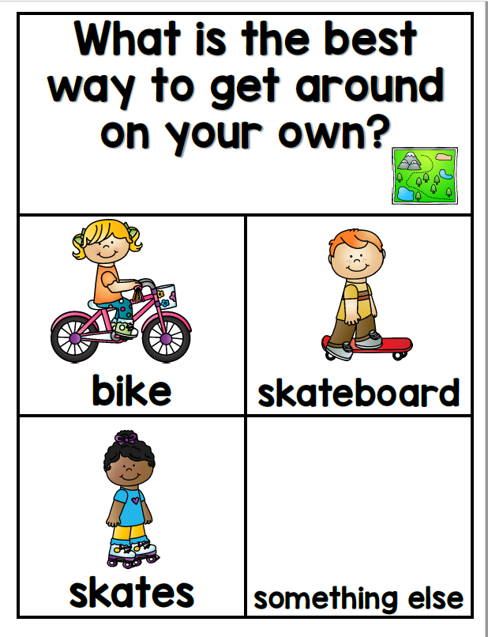
Today’s Opinion Writing Question
Remember to THINK, DECIDE and EXPLAIN out loud to your grown up before you start writing.
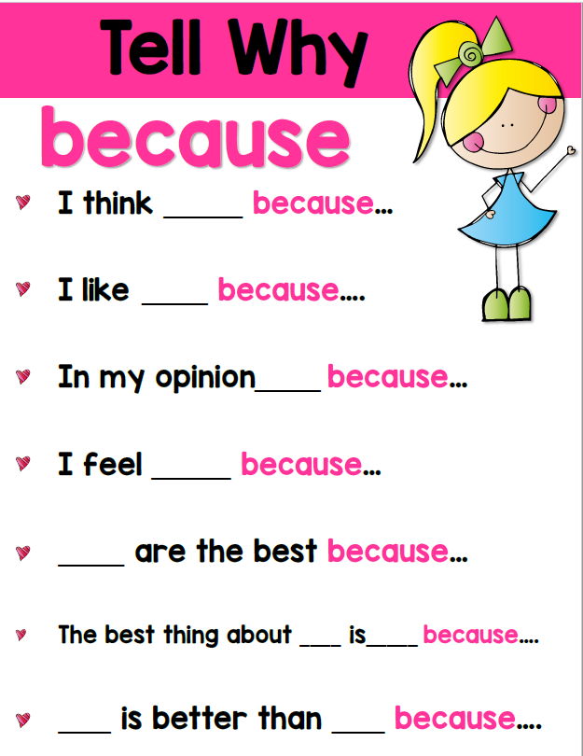

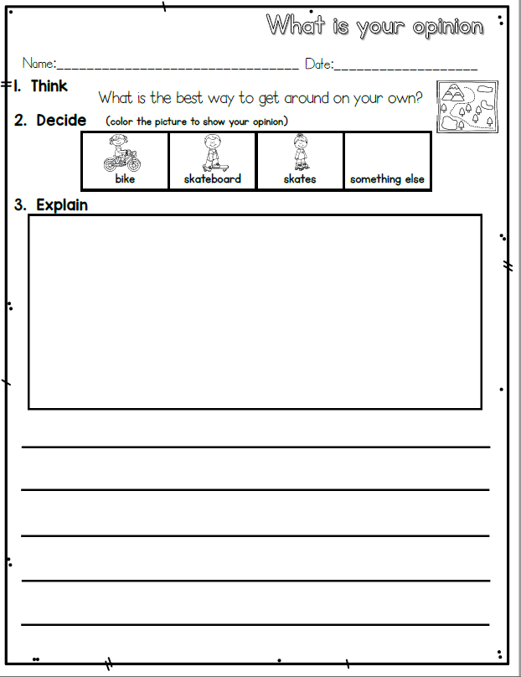
What are you doing well? GLOW Ask your grown up to look at your writing and complement you about your work.
Then ask them to help you look for 1 thing you can add to your writing to help you GROW as a writer using this rubric.
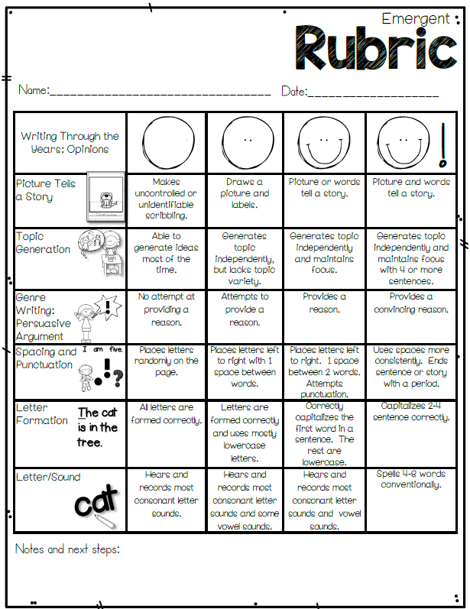
Extension: If you were able to get ALL on the Emergent Rubric – you are ready for the Early Writer Rubric on the next page.
