Which standards are we working on during the 4th quarter?
Kindergarten English Language Arts Georgia Standards of Excellence (ELA GSE)
¬ Text Types and Purposes
ELAGSEKW1: Use a combination of drawing, dictating, and writing to compose opinion pieces in which they tell a reader the topic or the name of the book they are “writing” about and state an opinion or preference about the topic or book (e.g., My favorite book is…).
¬ Production and Distribution of Writing
ELAGSEKW5: With guidance and support from adults, respond to questions and suggestions from peers and add details to strengthen writing as needed.
Today’s Opinion Writing Prompt Question
(Remember to THINK, DECIDE and EXPLAIN out loud to your grown up before you start writing.)
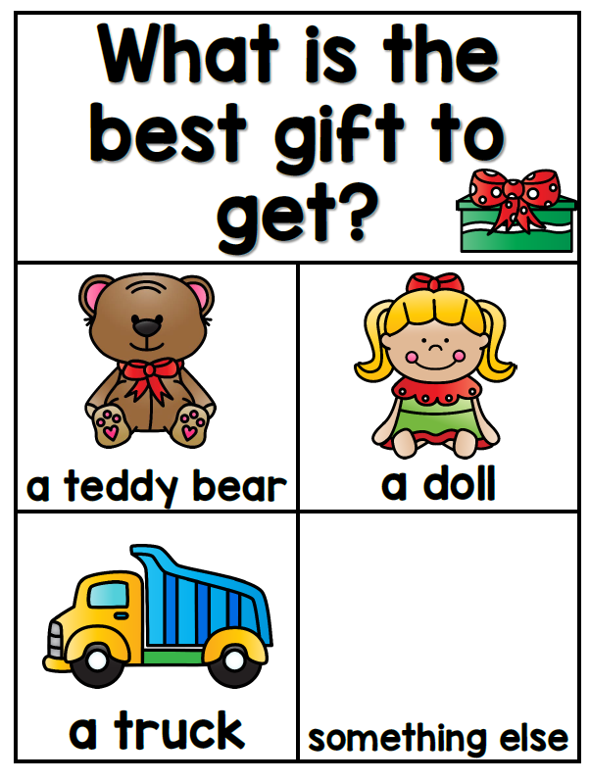

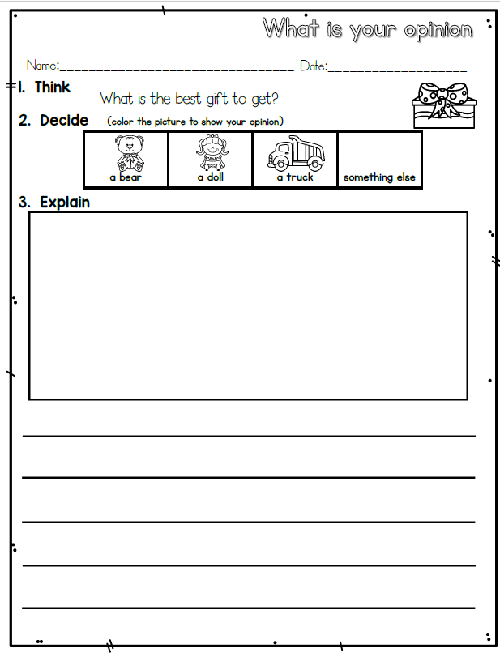

Be sure you tell why
I think ___________ because__________
I like_____________ because__________
__________ are the best because…
What are you doing well? GLOW Ask your grown up to look at your writing and complement you about your work. Then ask them to help you look for 1 thing you can add to your writing to help you GROW as a writer using this rubric.
Extension: If you were able to get ALL 😊 on the Emergent Rubric – you are ready for the Early Writer Rubric on the next page.

