Sight Words to Focus on this Week:
write go see number saw
*this
*she
*review words
Modified Sight Word List:
he she and then
-en Word Family Words
men hen pen ten

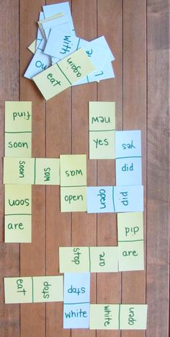
Using paper or post-it notes, write each Sight Word, Word Family, or CVC word two times. With each players’ set of words, they will need to connect to the words already on the table. This is played the same way we would play dominoes! This game can be modified to meet the learners’ needs.
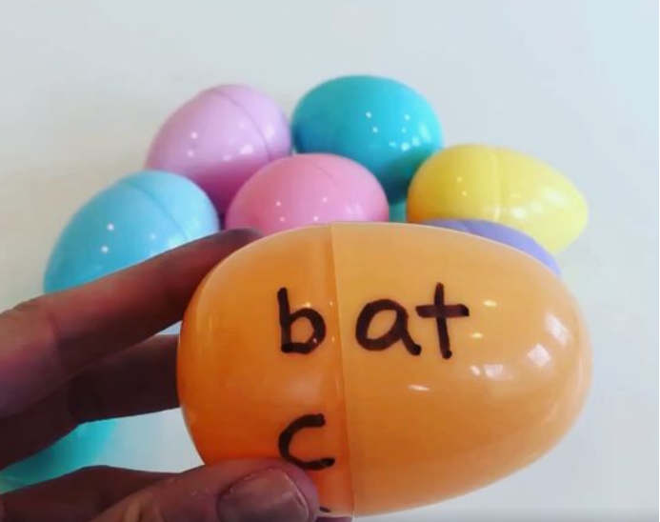
If you have eggs at home, you can easily create word families that kids can create simply by turning half of the egg. Kids can then read the words and use them in sentences.

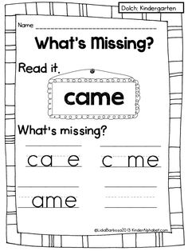
This activity is one that the kids should all be used to playing during Guided Reading and/or Phonics time! They love to play this! The teacher shares the entire word, kids/teacher read the word, the teacher then erases a letter and kids need to write the word with the missing letter back in place.

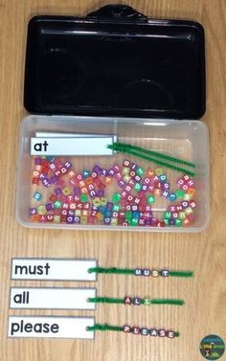
IF you have letter beads at home, you could spell Sight Words to match words on cards. If you don’t have beads or chenille craft sticks, but you do have a game with letter tiles, you could play this way, too!

