Parents,
Just like we might watch a cooking show to learn tips to create a wonderful recipe or a soccer player watches a video tape of a star athlete scoring an amazing goal, teachers use similar techniques to illustrate good writing to our students. We read “mentor texts” to our students to show them a model of what good writing looks like!
Before your child writes their opinion piece today – please share this story about opinions.

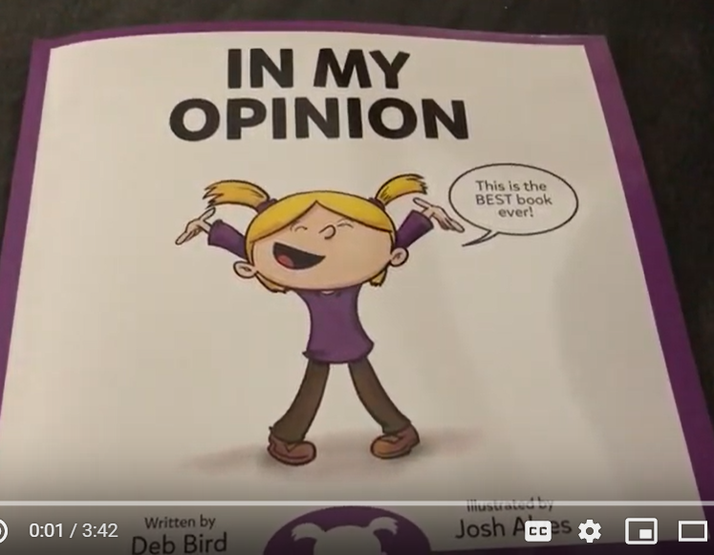
https://www.youtube.com/watch?v=oYtt_CS4o8o

